PHASE 1: Literature Study, Theoretical Analysis and Preliminary Design
Duration: July to August
Status: Completed
Objective: To establish the theoretical and design basis of the hydraulic McKibben muscle actuator.
Work Completed
- Literature review of McKibben muscle actuators.
- Study of pneumatic and hydraulic actuation.
- Study of the effect of pressure on actuator force.
- Study of braid geometry and braid angle.
- Study of actuator contraction.
- Theoretical force calculations.
- Pressure and contraction calculations.
- Preliminary actuator sizing.
- CAD modelling of the bladder & CAD modelling of the braided sheath.xxxxxx
- Preliminary actuator assembly development.
Preliminary Actuator Design Parameters
Parameter | Value
Actuator type | Hydraulic McKibben muscle
Total actuator length | 300 mm
Active actuator length | 250 mm
Upper end section | 25 mm
Lower end section | 25 mm
Nominal initial diameter | 40 mm
Target contraction | 20 to 25%
Maximum contraction displacement | 50 to 62.5 mm
Minimum operating pressure | 0 bar
Maximum operating pressure | 6 bar
Pressure increment | 1.5 bar
Test pressure levels | 0, 1.5, 3, 4.5, 6 bar
Initial test load | 0 kg
Minimum payload considered | 5 kg
Equivalent payload force | 49.05 N
Test orientation | Vertical
Dimensional Relationship
L_{total} = L_{active} + L_{e1} + L_{e2}
300 mm = 250 mm + 25 mm + 25 mm
PHASE 2: Final Actuator Specification and Specimen Preparation
Duration: September, Week 1
Objective: To freeze the actuator geometry and prepare the test specimen before experimental testing.
Activities
- Finalize bladder material.
- Finalize bladder wall thickness.
- Measure bladder inner and outer diameter.
- Finalize braided sheath material.
- Measure braid length.
- Measure initial braid angle.
- Finalize end fitting geometry.
- Assemble the complete actuator.
- Assign a specimen identification number.
- Record all initial dimensions.
Specimen Specification Table
Component | Parameter | Value
Bladder | Material | Final selected material
Bladder | Total length | 300 mm
Bladder | Active length | 250 mm
Bladder | Outer diameter | 40 mm nominal
Bladder | Inner diameter | Measured after material selection
Braided sheath | Material | Final selected material
Braided sheath | Active length | 250 mm
Braided sheath | Initial braid angle | 20° & 25°
Braided sheath | Initial diameter | Measured after assembly
Upper end fitting | Length | 25 mm
Lower end fitting | Length | 25 mm
Complete actuator | Total length | 300 mm
Output
Complete actuator specimen specification sheet.

PHASE 3: Test Rig Fabrication and Commissioning
Duration: September, Week 2
Objective: To develop and validate a vertical test rig for measuring pressure, force, contraction, deformation, and structural response.
Test Rig Configuration
The rig should include:
- Fixed upper mounting.
- Lower moving mounting.
- Vertical guide arrangement.
- Load application arrangement.
- Pressure supply.
- Pressure measurement.
- Force measurement.
- Displacement measurement.
- Diameter measurement procedure.
- Safety enclosure.
Test Rig Requirements
Parameter | Requirement
Maximum actuator length | 300 mm
Maximum expected contraction | 62.5 mm
Recommended displacement range | 0 to 100 mm minimum
Maximum operating pressure | 6 bar
Recommended pressure sensor range | Minimum 0 to 10 bar
Minimum payload | 5 kg
Equivalent load | 49.05 N
Recommended force sensor capacity | Minimum 100 N
Test orientation | Vertical
Upper mounting | Fixed
Lower mounting | Moving
Alignment | Concentric with actuator axis

Activities
- Fabricate the frame.
- Install upper and lower fixtures.
- Check concentricity.
- Install pressure measurement.
- Install force measurement.
- Install displacement measurement.
- Check load application.
- Conduct dry-run testing.
- Calibrate instruments.
Output
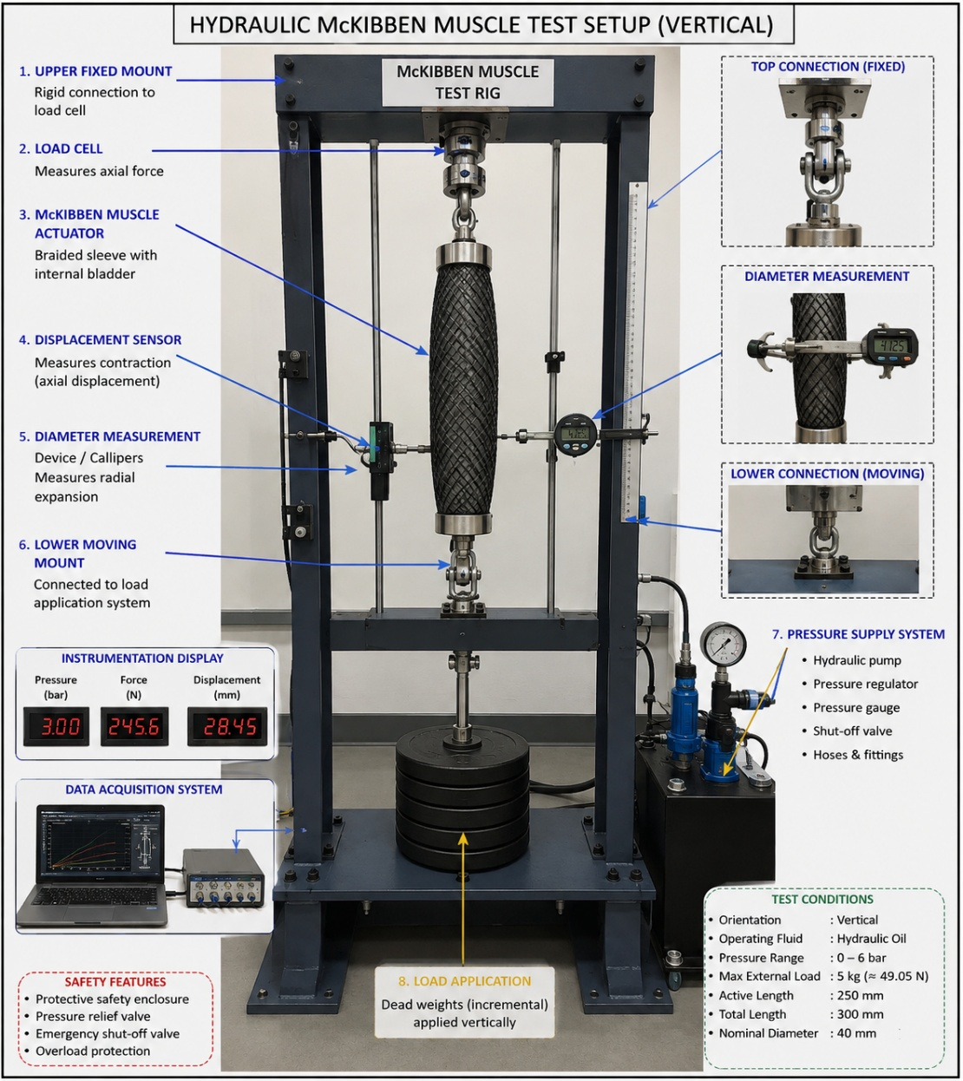
Commissioned test rig.

PHASE 4: Baseline Characterization and Leakage Testing
Duration: September, Week 3 to Week 4
Objective: To establish the initial physical condition of the actuator before integrity testing.
Initial Measurements
Parameter | Measurement
Total length | mm
Active length | mm
Initial diameter | mm
Bladder wall thickness | mm
Initial braid angle | Degree
Actuator mass | kg or g
Initial external load | 0 kg
Test 1: Visual Inspection
Inspect:
- Bladder surface.
- Braided sheath.
- End fittings.
- Sealing regions.
- Braid uniformity.
Test 2: Leakage Test
Apply pressure incrementally.
Leakage Test Matrix
Test ID | Pressure | External Load | Hold Condition | Observation
B1 | 0 bar | 0 kg | Initial | Baseline
B2 | 1.5 bar | 0 kg | Hold | Leakage check
B3 | 3 bar | 0 kg | Hold | Leakage check
B4 | 4.5 bar | 0 kg | Hold | Leakage check
B5 | 6 bar | 0 kg | Hold | Leakage check
Measurements
Pressure, leakage, actuator length, diameter, and visible deformation.
Output
Baseline condition and initial pressure response.

PHASE 5: Elastic Integrity Validation
Duration: October, Week 1 to Week 3
Objective: To determine the elastic behaviour and recovery characteristics of the actuator under repeated pressurization.
Constant Parameters
Parameter | Value
Total actuator length | 300 mm
Active actuator length | 250 mm
Initial nominal diameter | 40 mm
Test orientation | Vertical
Maximum operating pressure | 6 bar
Pressure levels | 0, 1.5, 3, 4.5, 6 bar
Initial external load | 0 kg
Test 1: Pressure Versus Contraction
Test ID | Pressure | Initial Length | Contraction
E1 | 0 bar | L₀ | 0%
E2 | 1.5 bar | L₀ | Calculate
E3 | 3 bar | L₀ | Calculate
E4 | 4.5 bar | L₀ | Calculate
E5 | 6 bar | L₀ | Calculate
Contraction:
ε = (L0 − L) / L0 × 100
Test 2: Radial Expansion
Test ID | Pressure | Initial Diameter | Pressurized Diameter | Radial Change
R1 | 0 bar | D₀ | D | 0
R2 | 1.5 bar | D₀ | D | Calculate
R3 | 3 bar | D₀ | D | Calculate
R4 | 4.5 bar | D₀ | D | Calculate
R5 | 6 bar | D₀ | D | Calculate
Test 3: Loading and Unloading
Apply: 0 → 1.5 → 3 → 4.5 → 6 bar
Then: 6 → 4.5 → 3 → 1.5 → 0 bar
Measure contraction at every pressure level.

Test 4: Elastic Recovery
After complete depressurization, measure:
Final recovered length, Lr
Final recovered diameter, Dr
Calculate residual deformation.
Test 5: Repeatability
Test ID | Pressure | Number of Cycles
ER1 | 3 bar | 5
ER2 | 3 bar | 10
ER3 | 4.5 bar | 25
ER4 | 4.5 bar | 50
Output
- Pressure versus contraction curve.
- Pressure versus diameter curve.
- Hysteresis curve.
- Elastic recovery data.
- Residual deformation data.
- Repeatability data.

PHASE 6: Structural Integrity Validation
Duration: October, Week 4 to November, Week 2
Objective: To validate the physical and structural stability of the complete actuator.
Constant Parameters
Parameter | Value
Total actuator length | 300 mm
Active actuator length | 250 mm
Nominal diameter | 40 mm
Maximum operating pressure | 6 bar
Test orientation | Vertical
Actuator alignment | Concentric
Inspection | Before and after each test
Test 1: Pressure Ramp Test
Increase pressure from 0 to 6 bar.
Pressure levels: 0, 1.5, 3, 4.5, 6 bar.
Observe: Leakage, Local bulging, Braid movement, Braid slippage, End-fitting movement, Structural deformation
Test 2: Pressure Hold Test
Test ID | Pressure | External Load | Measurement
S1 | 3 bar | 0 kg | Pressure stability
S2 | 4.5 bar | 0 kg | Pressure stability
S3 | 6 bar | 0 kg | Pressure stability
Record pressure drop, length change, diameter change, and leakage.
Test 3: External Load Test
Use loads up to the design payload.
Test ID | External Load | Equivalent Force
L1 | 0 kg | 0 N
L2 | 1 kg | 9.81 N
L3 | 2 kg | 19.62 N
L4 | 3 kg | 29.43 N
L5 | 4 kg | 39.24 N
L6 | 5 kg | 49.05 N

Test 4: Combined Pressure and Load Test
Test each load at selected pressure levels.
Pressure | Load Range
1.5 bar | 0 to 5 kg
3 bar | 0 to 5 kg
4.5 bar | 0 to 5 kg
6 bar | 0 to 5 kg
Measure: Force, Contraction, Diameter, Leakage, Structural deformation
Output
- Structural integrity assessment.
- Safe pressure range.
- Safe load range.
- Observed structural failure modes.

PHASE 7: Force and Contraction Performance Testing
Duration: November, Week 3 to Week 4
Objective: To experimentally validate force generation and contraction.
Test Matrix
Pressure | 0 kg | 1 kg | 2 kg | 3 kg | 4 kg | 5 kg
0 bar | Test | Test | Test | Test | Test | Test
1.5 bar | Test | Test | Test | Test | Test | Test
3 bar | Test | Test | Test | Test | Test | Test
4.5 bar | Test | Test | Test | Test | Test | Test
6 bar | Test | Test | Test | Test | Test | Test
Tests: Free contraction test, Loaded contraction test, Force versus pressure test, Contraction versus pressure test, Blocked-force test, if the rig and sensor arrangement support it.
Output
- Force versus pressure graph.
- Contraction versus pressure graph.
- Load versus contraction graph.
- Experimental versus theoretical comparison.

PHASE 8: Cyclic and Endurance Testing
Duration: December, Week 1 to Week 2
Objective: To determine degradation of actuator performance under repeated operation.
Cyclic Test Matrix
Test ID | Pressure | External Load | Number of Cycles
C1 | 3 bar | 0 kg | 100
C2 | 3 bar | Selected load | 500
C3 | 4.5 bar | Selected load | 1,000
C4 | 6 bar | Selected safe load | Final endurance cycle block
After each cycle block, measure: Maximum contraction, Generated force, Recovered length, Recovered diameter, Leakage, Braid condition, End-fitting condition
Output
- Cycle versus contraction.
- Cycle versus force.
- Performance degradation.
- Elastic degradation.
- Structural degradation.
- Failure observations.

PHASE 9: Final Validation and Post-Test Inspection
Duration: December, Week 3
Objective :To compare the actuator condition before and after all testing.
Final Inspection Matrix
Parameter | Before Testing | After Testing
Total length | L_{total} | L_{final}
Active length | L_{o} | L_{final}
Diameter | D_{o} | D_{final}
Wall thickness | T_{o} | t_{final}
Braid angle | θ_{o} | θ_{final}
Maximum contraction | Initial | Final
Maximum force | Initial | Final
Leakage condition | Initial | Final
Bladder condition | Initial | Final
Braid condition | Initial | Final
End fitting condition | Initial | Final
Final Tests
- Leakage test.
- Pressure versus contraction test.
- Pressure versus force test.
- Elastic recovery test.
- Short repeatability test.
- Final structural inspection.
Output
- Final actuator condition.
- Validated operating range.
- Performance retention.
- Elastic integrity assessment.
- Structural integrity assessment.

PHASE 10: Data Analysis and Final Documentation
Duration: December, Week 4
Objective: To analyze the complete experimental programme.
Activities
- Plot pressure versus contraction.
- Plot pressure versus force.
- Plot pressure versus diameter.
- Calculate hysteresis.
- Calculate elastic recovery.
- Calculate residual deformation.
- Compare pre-cycle and post-cycle performance.
- Compare theoretical and experimental force.
- Identify structural damage.
- Identify failure modes.
- Define the experimentally validated operating range.
Final Deliverables
- Complete test matrix.
- Test rig specification.
- Specimen dimensional drawing.
- Pressure-contraction curves.
- Pressure-force curves.
- Pressure-diameter curves.
- Hysteresis curves.
- Cyclic degradation curves.
- Elastic integrity report.
- Structural integrity report.
- Final validated McKibben muscle specification.

